Assignment 3

# 1.write a query to display the orders placed by customer with phone number 030-0074321

--1

SELECT o.OrderNUmber, c.id, c.FirstName, c.Phone FROM Orders as o, Custermer as c

WHERE o.Custermerid = c.id AND c.Phone='030-0074321';

# 2. fetching all the products which are available under Category ‘Seafood’.

--2

SELECT * FROM Product WHERE category ='SeaFood';

# 3.Display the orders placed by customers not in London

--3

select * From Orders as o INNER Join Custermer as c ON o.Custermerid = c.id

and c.Country != 'London';

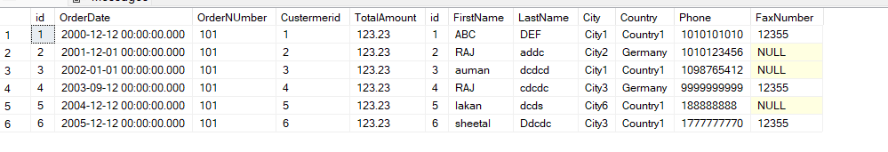

# 4. selects all the order which are placed for the product Chai.

--4

select * From Orders where id in

(Select OrderId from OrderItem as o Inner Join Product as p ON o.Productid = p.id and ProductName= 'Chai')

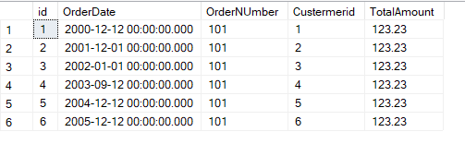

# 5.Write a query to display the name , department name and rating of any given employee

--5

SELECT e.Fname AS emp_name, d.Dname AS dept_name, e.rating FROM employee as e INNER JOIN department as d

ON e.depid=d.id;

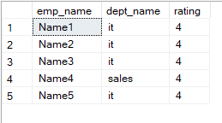

# 6.Print the Total price of orders which have the products supplied by 'Exotic Liquids' if the price is > 50 and also print it by Shipping company's Name

--6

alter table product_supply add availability_status varchar(40)

alter table product_supply add CompanyName varchar(20)

update product_supply set availability_status='out of stock',CompanyName='Company' where supplier_name='exotic liquids'

SELECT SUM(price) As Total,CompanyName

FROM product_supply

where price >50

GROUP BY supplier_name,CompanyName having supplier_name ='exotic liquids';

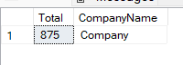

# 7. Display the employee details whose joined at first

--7

alter table employee add doj datetime;

update employee set doj =DATEADD(year,-2,GETDATE()) where Empid=1

update employee set doj =DATEADD(year,-4,GETDATE()) where Empid=2

update employee set doj =DATEADD(year,-7,GETDATE()) where Empid=3

update employee set doj =DATEADD(year,-8,GETDATE()) where Empid=4

update employee set doj =DATEADD(year,-1,GETDATE()) where Empid=5

select top(1) * from employee order by doj;



# 8. Display the employee details whose joined at recently

--8

select top(1) * from employee order by doj desc

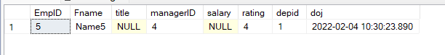

# 9. Write a query to get most expense and least expensive Product list (name and unit price).

--9

select ProductName ,UnitPrice from Product where UnitPrice in((

select top(1) UnitPrice from Product order by UnitPrice desc),(

select top(1) UnitPrice from Product order by UnitPrice));

